
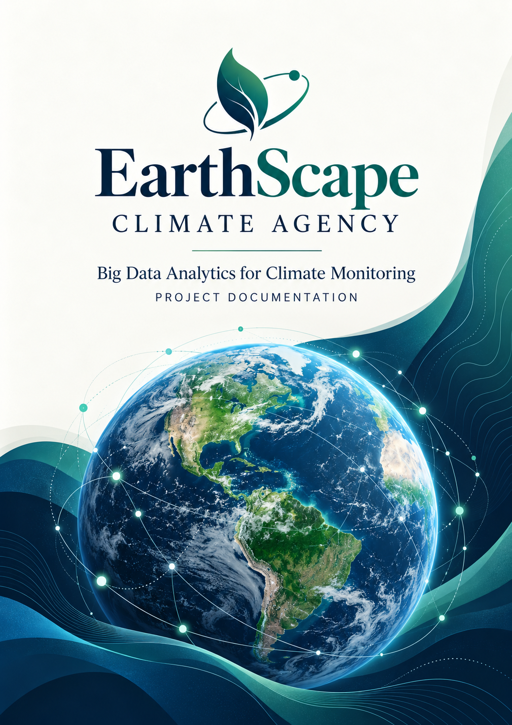
2026



Table of Contents
Contents
CERTIFICATE OF COMPLETION………………………………………………………............................................................................................................4
ACKNOWLEDGEMENT 5
INTRODUCTION 6
PROBLEM STATEMENT 6
CUSTOMER REQUIREMENTS 8
SPECIFICATIONS – ONYXFIT 8
Functional Requirements 8
Non-Functional Requirements 11
SCOPE OF THE PROJECT 14
PROPOSED SOLUTIONS 15
HARDWARE/ SOFTWARE REQUIREMENTS 16
System Architecture and 18
Design of the System 18
User Registration 18
User Login 19
User Profiles 20
Edit Profiles 20
Workout Tracking 21
Nutrition Tracking 21
Progress Tracking 22
User Dashboard 23
Notifications and Alerts 24
Reminders 25
Search and Filtering: 25
Feedback and Support 26
Mobile Responsiveness 27
Setting And Preferences 28
Reporting And Export 28
Website 29
PROJECT TASK SHEET 31
PROJECT REVIEW AND MONITORING TABLE 32
UNIT TESTING CHECKLIST 33
FINAL CHECK LIST 34


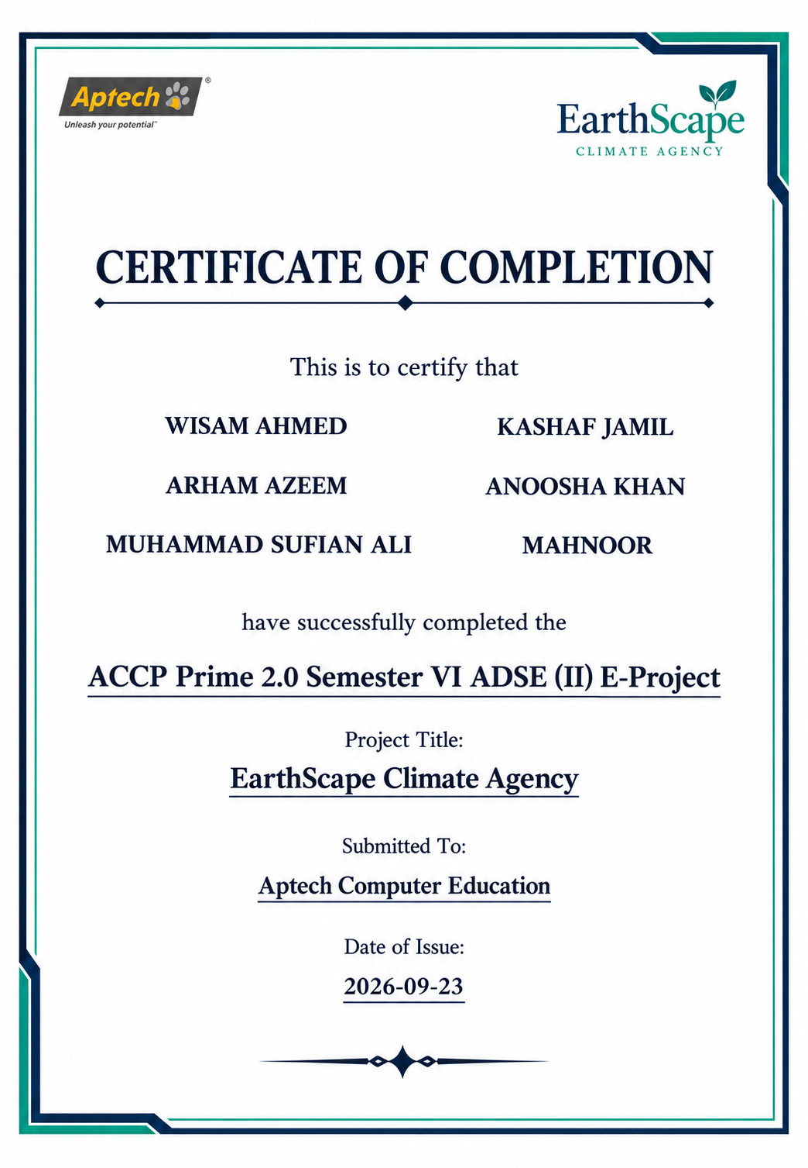

CERTIFICATE OF COMPLETION

ACKNOWLEDGEMENT

All praise and gratitude belong to Almighty Allah, whose blessings gave us the strength, patience, and ability to undertake our project, EarthScape Climate Agency.
We sincerely thank our supervisor, Sir Muhammad Umer, for his guidance, encouragement, and constructive feedback throughout the project. His support helped us develop our understanding of big data technologies and their application to climate data analysis.
We are grateful to Aptech Computer Education and our faculty members for providing the learning environment and technical foundation needed to carry out this project as part of ACCP Prime 2.0, Semester VI, ADSE (II).
We also appreciate the efforts and cooperation of our team members: Wisam Ahmed, Kashaf Jamil, Arham Azeem, Anoosha Khan, Muhammad Sufian Ali, and Mahnoor. Working together allowed us to share ideas, address challenges, and learn from one another.
Finally, we thank our families and friends for their patience, encouragement, and support throughout this learning journey.

INTRODUCTION


EarthScape Climate Agency is a proposed big data analytics system designed to support climate monitoring, analysis, and informed decision-making. It aims to bring together climate-related data from sources such as satellites, weather stations, and environmental sensors to help analysts understand changing environmental con ditions.
The system uses Hadoop and the Hadoop Distributed File System (HDFS) to process and store large volumes of climate data. It is designed to support historical data analysis and real-time monitoring, allowing users to explore climate patterns, identify anomalies, and examine relationships between environmental variables. Machine learning models are intended to support predictive analysis of climate trends.
Interactive dashboards and visualizations will present analytical results in an accessible format. The system also includes role-based access, configurable alerts, and user support features. By combining data management, analytics, and visualization, EarthScape Climate Agency aims to provide a structured platform for investigating climate change and supporting environmental planning.

Background & Necessity

Climate change presents significant challenges to ecosystems, communities, and economies. Greenhouse gas emissions, deforestation, and changes in land use contribute to shifts in climate patterns. Understanding these changes requires the analysis of environmental observations collected across different locations and time periods.
Satellites, weather stations, and environmental sensors generate large and diverse datasets. These records may arrive in different formats and contain missing, inconsistent, or incomplete values. Managing them through separate files or manual processes can make it difficult to identify long-term trends, compare observations, and detect unusual conditions promptly.
EarthScape Climate Agency is proposed to address these challenges through a centralized analytical platform supported by distributed storage and processing. Hadoop-based technologies provide a foundation for handling growing data volumes, while data preparation and analytical methods help turn raw observations into useful information.
The project is necessary to support the following needs:
- Scalable data management: Store and process increasing volumes of climate-related data.
- Integrated analysis: Bring together observations from multiple sources for a more comprehensive view.
- Pattern and anomaly detection: Identify trends, relationships, and unusual environmental conditions.
- Predictive insights: Use machine learning to estimate future climate trends, subject to data quality and model validation.
- Accessible reporting: Present findings through dashboards and visualizations that stakeholders can explore.
- Timely awareness: Notify users when monitored conditions exceed predefined thresholds.
Through these capabilities, the project aims to help analysts and decision-makers evaluate environmental conditions and plan appropriate responses.



PROBLEM STATEMENT

EarthScape Climate Agency needs to manage and analyze large volumes of climate-related data collected from satellites, weather stations, and environmental sensors. These datasets vary in format, frequency, and quality, making it challenging to combine observations and obtain consistent analytical results.
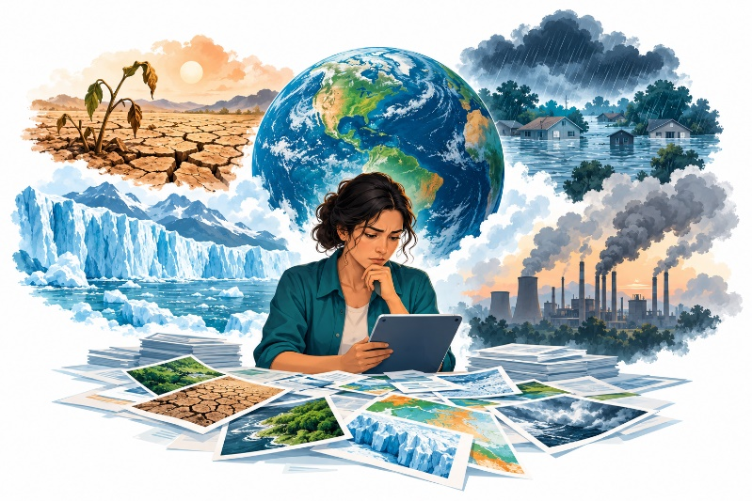
Manual analysis and conventional file-based approaches become difficult to maintain as data volumes increase. Missing values, inconsistent records, and fragmented data sources can further delay analysis and reduce the reliability of findings. Without an integrated platform, analysts may struggle to identify climate trends, detect anomalies, and communicate significant environmental changes promptly.
The project therefore aims to develop a scalable big data analytics system that integrates data ingestion, storage, processing, predictive analysis, and visualization. Using Hadoop and HDFS, the proposed system will support distributed management of climate datasets. Machine learning models, interactive dashboards, and configurable alerts will help users explore patterns and support informed environmental decision-making.

Project Objectives

The main objective of EarthScape Climate Agency is to develop a scalable big data analytics platform for managing and analyzing climate-related data. The project aims to achieve the following goals:
- Integrate diverse data sources: Collect climate-related datasets from satellites, weather stations, and environmental sensors, supporting historical and real-time observations.
- Provide scalable storage: Use the Hadoop Distributed File System (HDFS) to store large datasets with fault tolerance and efficient organization.
- Process climate data efficiently: Apply Hadoop MapReduce for distributed processing and handle missing or incomplete records through appropriate data preparation methods.
- Identify patterns and anomalies: Analyze environmental observations to discover climate trends, unusual conditions, and relationships between variables.
- Support predictive analysis: Develop and evaluate machine learning models for climate trend prediction and anomaly detection.
- Present accessible insights: Provide interactive dashboards that allow users to explore observations, analytical findings, and predictions.
- Enable timely notifications: Generate configurable alerts when monitored conditions exceed predefined thresholds.

- Control access securely: Implement authentication and role-based authorization for administrators and analysts.
- Support system use and maintenance: Provide user assistance, documentation, and performance monitoring.

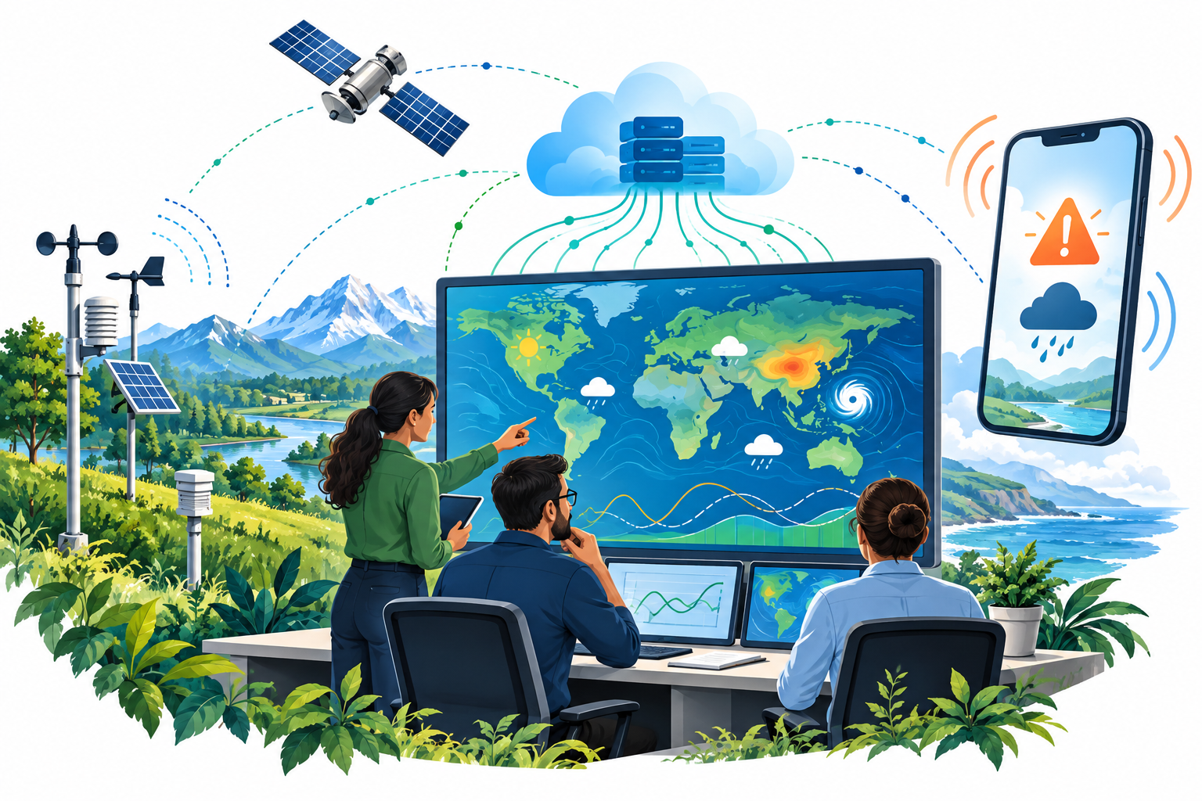

Scope of the Project

EarthScape Climate Agency covers the development of a climate data management and analytics platform. Its scope includes data ingestion, distributed storage, processing, machine learning, visualization, and notifications. Data Collection and Preparation
The system will support the ingestion of available satellite, weather station, and environmental sensor datasets in compatible formats. Data preparation will include validation, standardization, and appropriate handling of missing or incomplete values.
Distributed Storage and Processing
HDFS will provide distributed storage for climate datasets. Hadoop MapReduce will support batch processing, while streaming capabilities will be integrated to handle available real-time data sources.
Climate Analysis and Prediction
The platform will analyze historical observations to identify trends, anomalies, and correlations. Machine learning models will support predictive analysis, with their performance assessed using suitable evaluation methods.

Dashboards and Alerts
Interactive dashboards will display climate patterns, analytical results, and model predictions. Users will be able to explore information through supported filters and receive notifications based on configurable thresholds.
User Management and Support
The system will provide secure login and role-based access for administrators and analysts. It will also include facilities for reporting issues, requesting assistance, and submitting feedback.
Security, Monitoring, and Documentation
The project will include data protection measures, backup procedures, and system performance monitoring. Documentation will explain the system architecture, processing workflows, machine learning models, and installation and usage procedures.
Scope Boundaries
The project focuses on analyzing available climate datasets rather than manufacturing satellites, weather stations, or sensors. Dataset coverage and real-time functionality will depend on accessible sources and infrastructure. Predictions and alerts will support analysis and decision-making; they will not serve as official emergency warnings or guarantee future climate conditions.

Functional Requirements

User Authentication and Authorization:
Implement a secure authentication system for users with different roles (e.g.,
administrators, analysts).
Define access controls to restrict data access based on user roles and responsibilities.
Data Ingestion:
The system should support the ingestion of diverse climate-related datasets, including satellite imagery, weather station records, and environmental sensor data.
Implement mechanisms to handle both historical and real-time data sources.
Ensure compatibility with common data formats used in climate science.
Data Storage:
Utilize the Hadoop Distributed File System (HDFS) for scalable and fault-tolerant storage of large climate datasets.
Implement data partitioning and organization strategies to optimize retrieval and processing.
Data Processing:
Implement Hadoop MapReduce jobs for parallel processing of climate data across distributed nodes.
Develop algorithms for the identification of climate patterns, anomalies, and correlations.
Include mechanisms to handle missing or incomplete data gracefully.
Real-time Data Processing:
Integrate real-time data streaming capabilities.
Ensure seamless integration with batch processing for a comprehensive analysis.
Machine Learning Models:
Develop machine learning models for predictive analysis of climate trends and impacts.
Include algorithms for anomaly detection, trend prediction, and correlation analysis.
Regularly update and refine models based on the latest available data.
Data Visualization:
Create interactive dashboards.
Develop visual representations of climate patterns, anomalies, and predictions.
Provide customizable and user-friendly interfaces for stakeholders to explore data.
Notifications and Alerts:
Set up automated notifications and alerts for stakeholders based on predefined thresholds for climate anomalies or significant events.
Enable configurable alerting mechanisms to notify users in real-time.
Feedback and Support:
A support system for users to contact for assistance, report issues, and provide feedback.

Non-Functional Requirements

Performance:
Implement monitoring tools to track system performance, resource utilization, and data processing times.
Include optimization strategies for enhancing the overall efficiency of the system.
Data Security:
Implement encryption mechanisms to secure sensitive climate data during storage and transmission.
Ensure compliance with relevant data protection regulations and standards.
Reliability:
Uptime: The application should aim for a minimum of 99% uptime, with scheduled maintenance communicated in advance.
Data Backup: Regular automated data backups must be performed to prevent data loss in case of system failures.
Scalability:
The architecture should support horizontal scaling to accommodate increased data volumes and processing demands.

Implement load balancing mechanisms for optimal resource utilization.
Performance Monitoring:
Implement monitoring tools to track system performance, resource utilization, and data processing times.
Include optimization strategies for enhancing the overall efficiency of the system.
Compliance and Standards:
Ensure adherence to relevant environmental data standards and protocols.
Comply with industry best practices for big data processing and analytics.
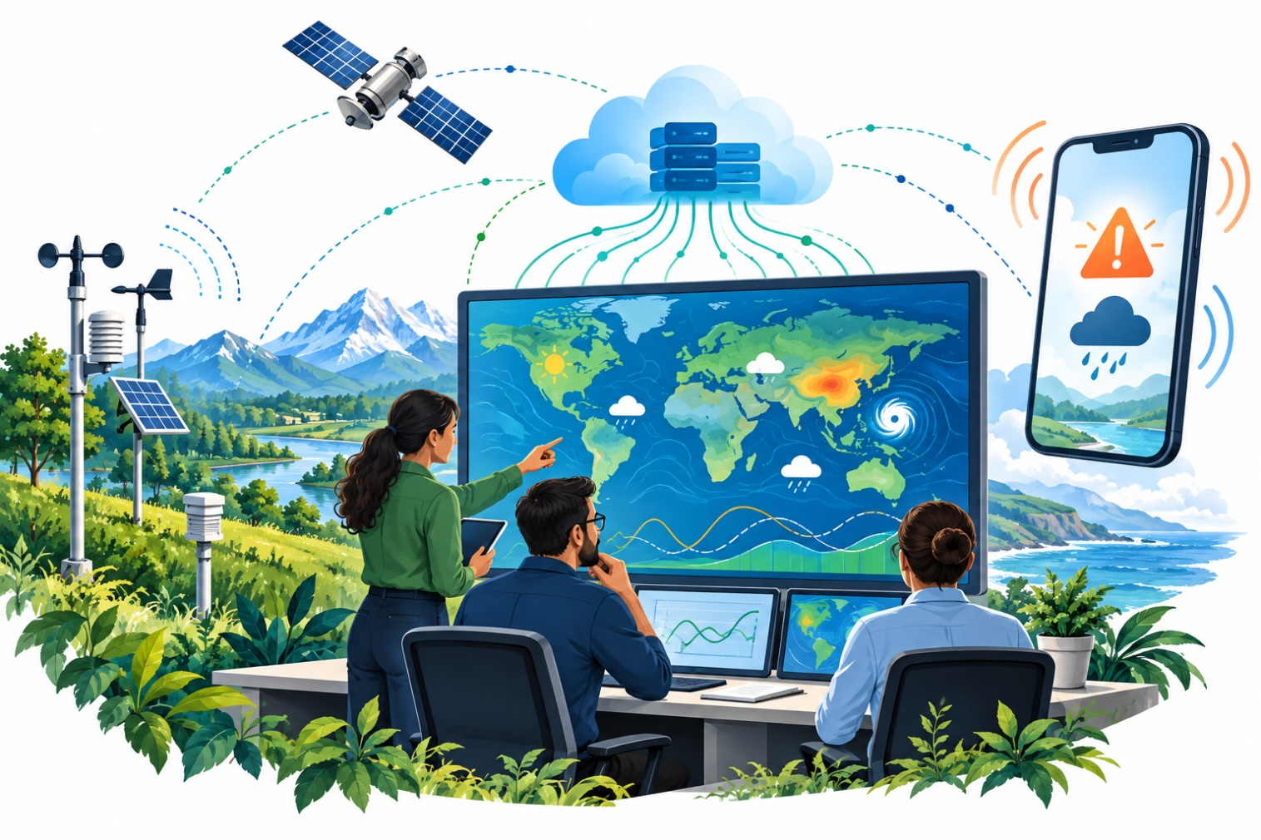

Hardware & Software Requirements

Hardware Requirements
- Minimum i5 with 4 Cores but i7 is recommended.
- 16 GB of RAM
- 500 GB of SSD storage
- Graphics Card
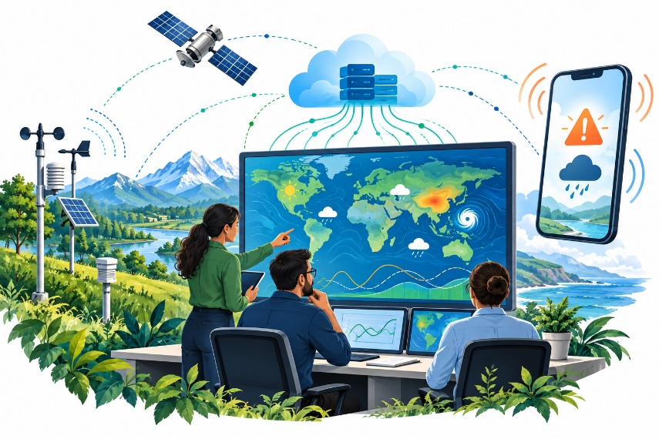
- 64Bit Windows 10 or higher

Software:
- Jupiter Anaconda Notebook 3
- RStudio
- Visual Code Studio / PyCharm
- Mongo Db Compass, and Shell
- Hadoop,HDFS and Apache server
- Tableau
- Impala server

Data Processing Workflow
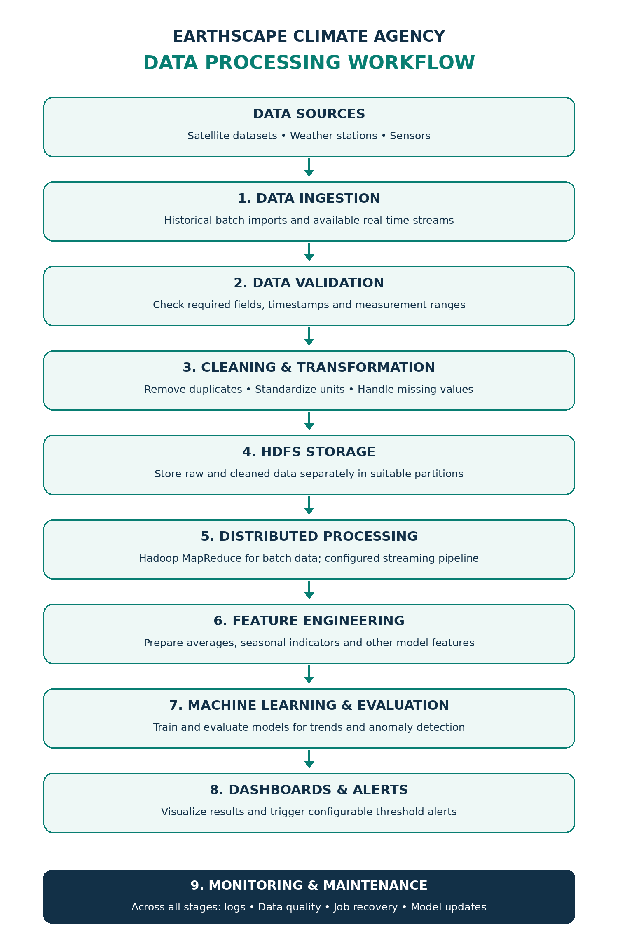

Machine Learning Models

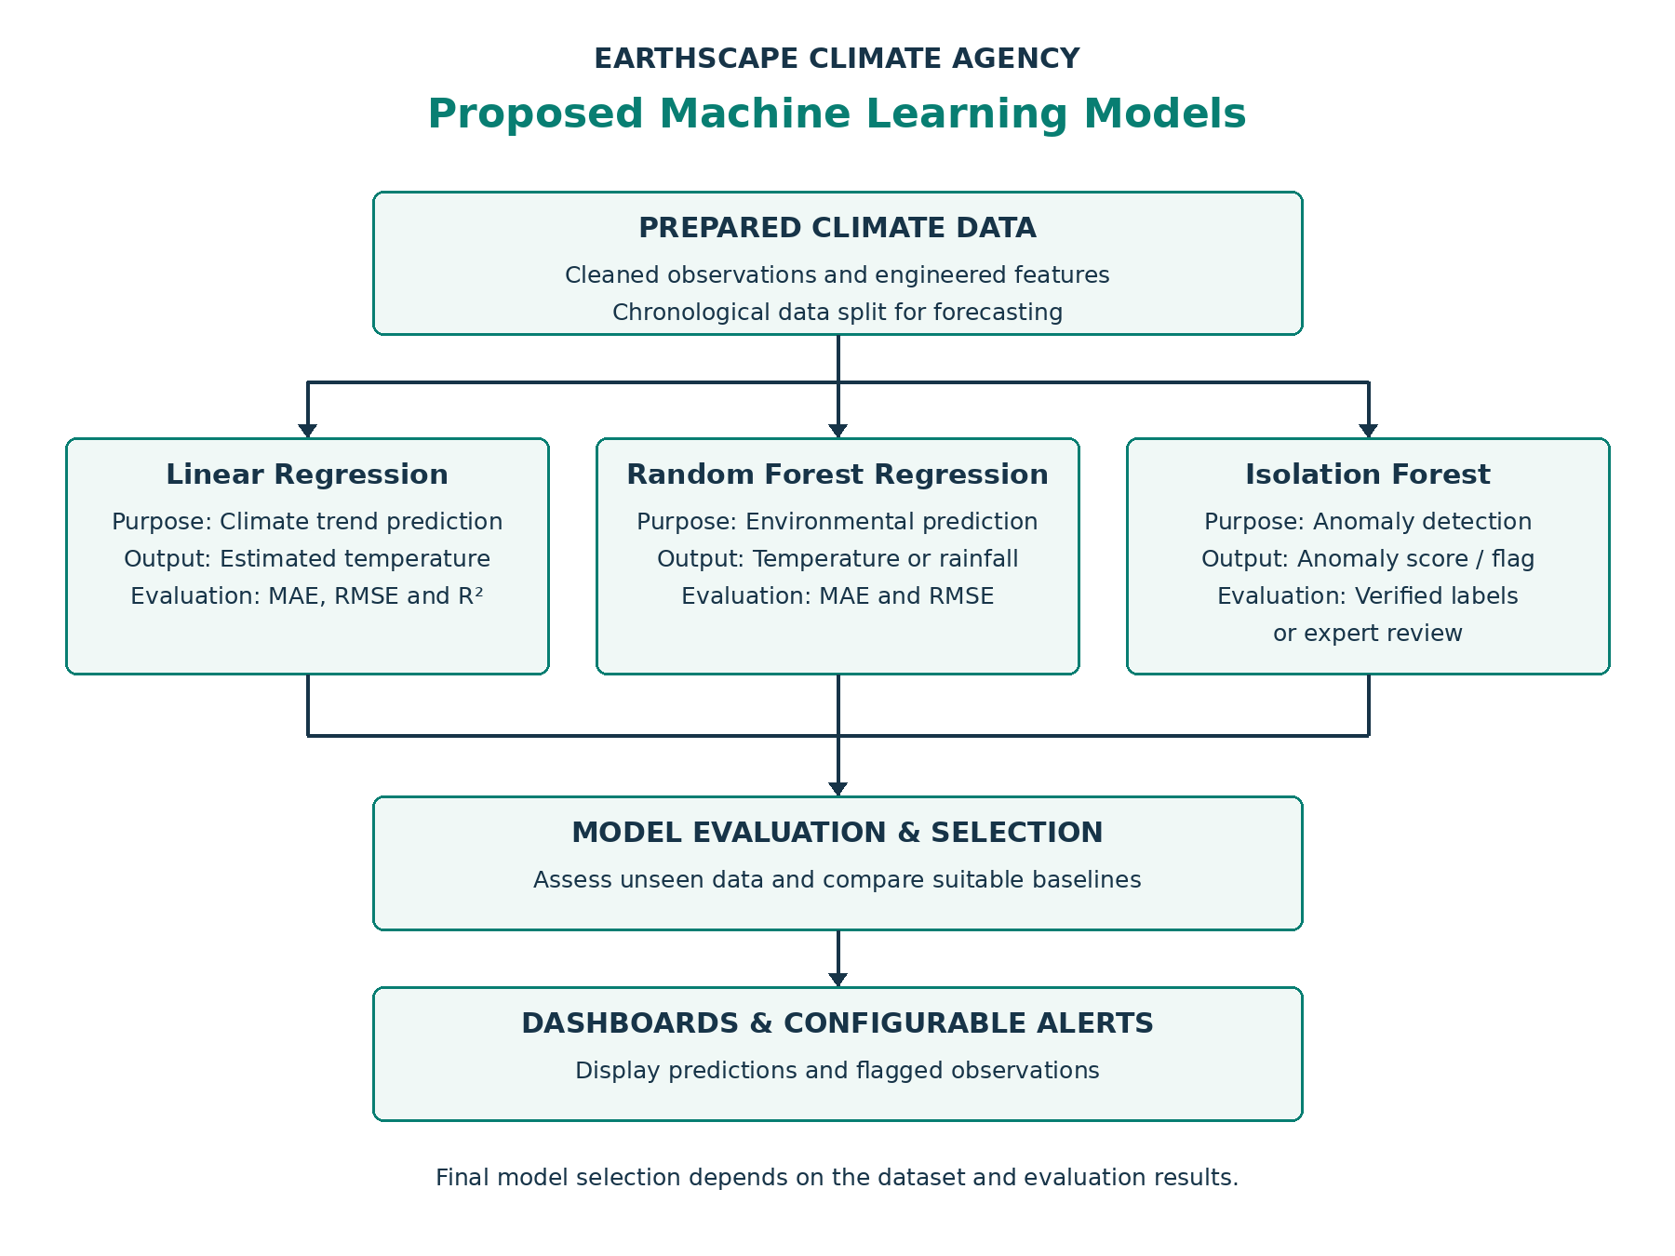

Dashboard Implementation
The EarthScape dashboard is a web application (FastAPI, MongoDB, Chart.js) that follows the project identity: the EarthScape logo in the top bar and on the sign-in page, the deep-teal and navy palette of this document, and the same serif headings. It is reached at http://127.0.0.1:8000 and is bound to the local machine only. The screenshots below were taken from the running system with real stored data; labels on every page say whether a value is gridded reanalysis (NASA POWER), modelled (Open-Meteo) or observed (OpenAQ).

Sign-in and role-based access
Users sign in with a personal account. Administrators additionally see User Management and Feedback Review; Analysts receive a permission-denied page for those routes.
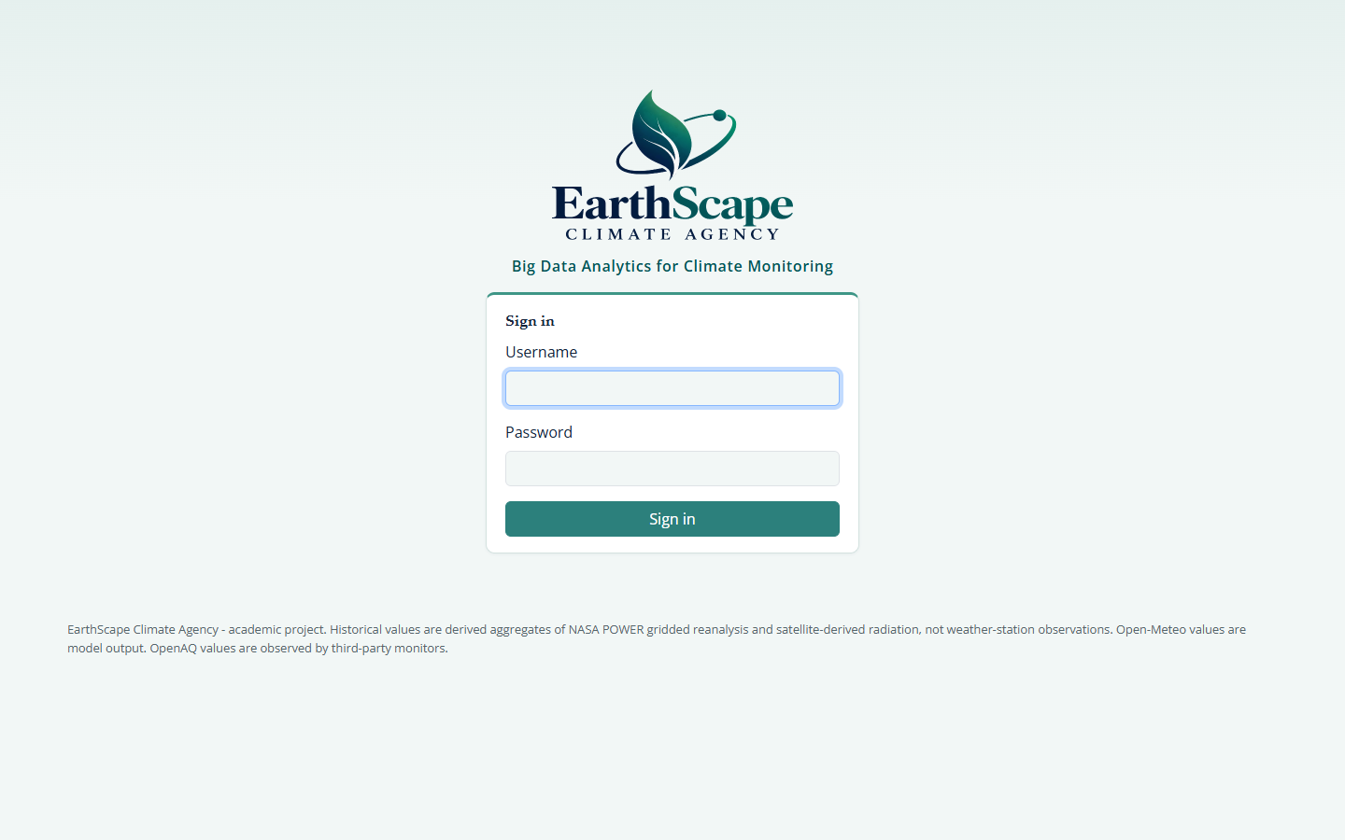
Figure A. Sign-in page with the EarthScape logo
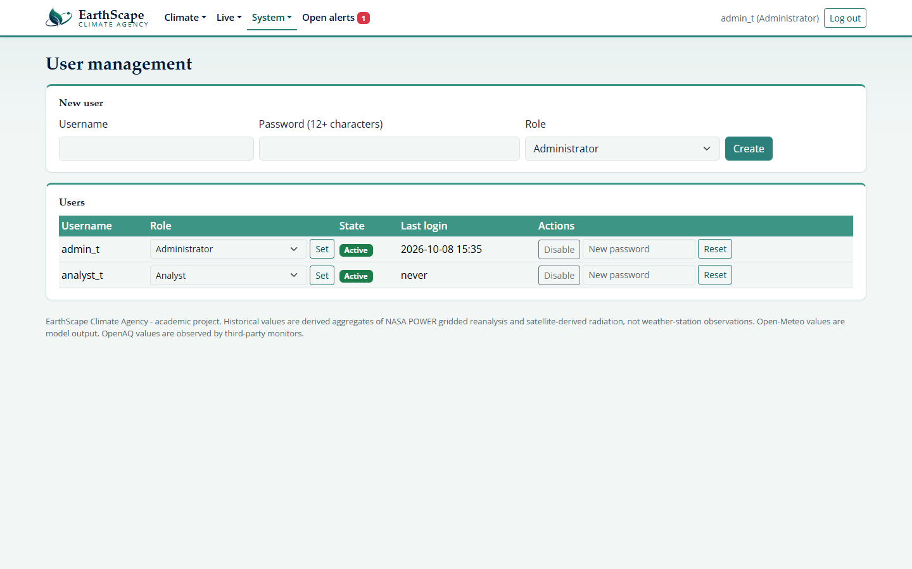
Figure B. User Management (Administrator only): create users, change roles, disable accounts, reset passwords

Historical climate (NASA POWER, processed with Hadoop MapReduce)
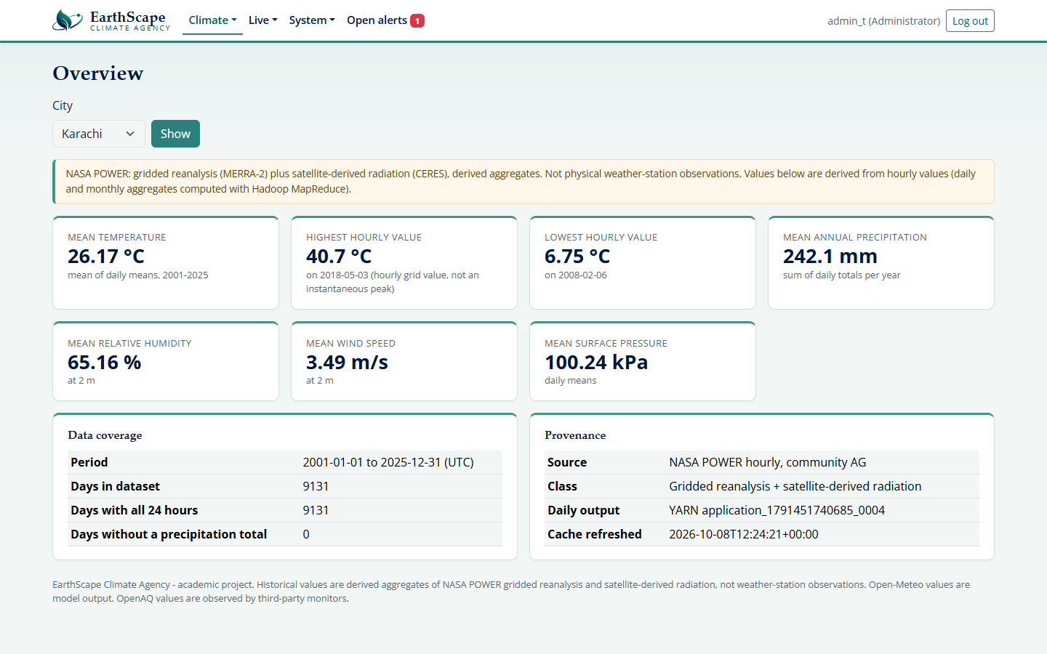
Figure C. Overview: key figures for the chosen city with the data-source label
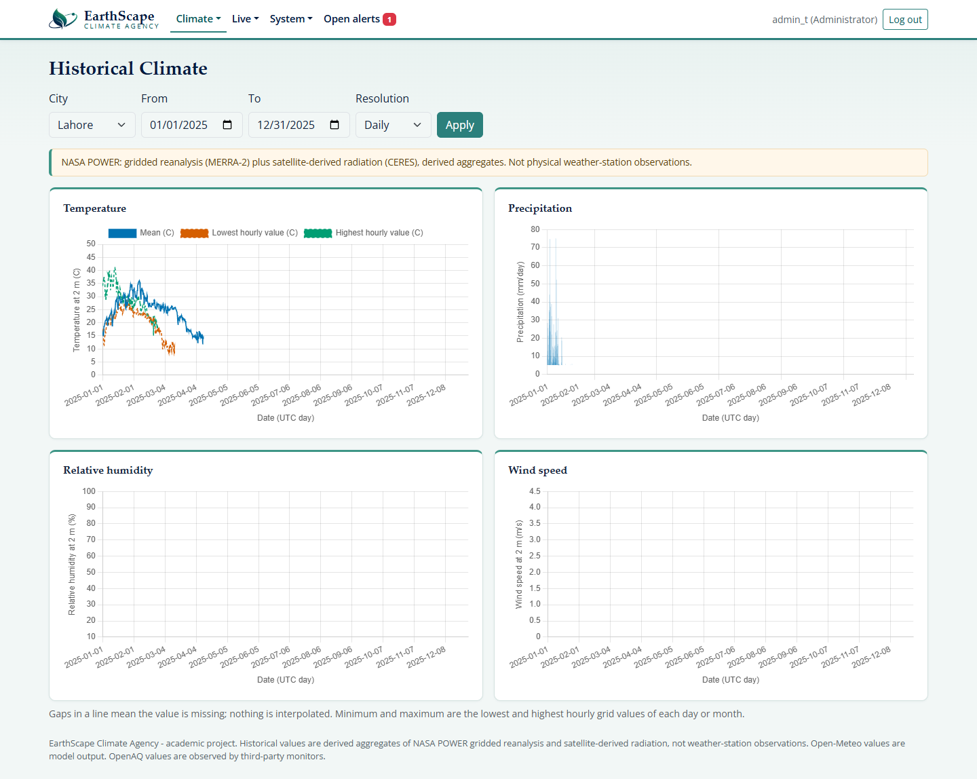
Figure D. Historical Climate: temperature, precipitation, humidity and wind with city, date and resolution filters
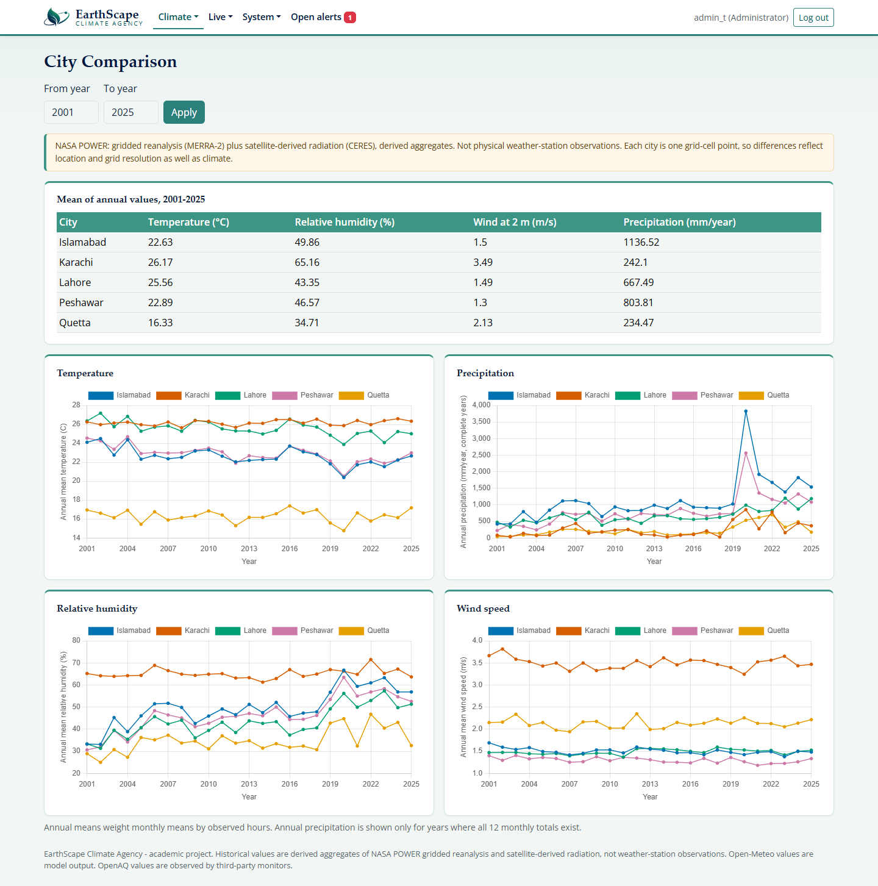
Figure E. City Comparison across Karachi, Lahore, Islamabad, Peshawar and Quetta

Analytics: trends, anomalies, correlation and forecasts
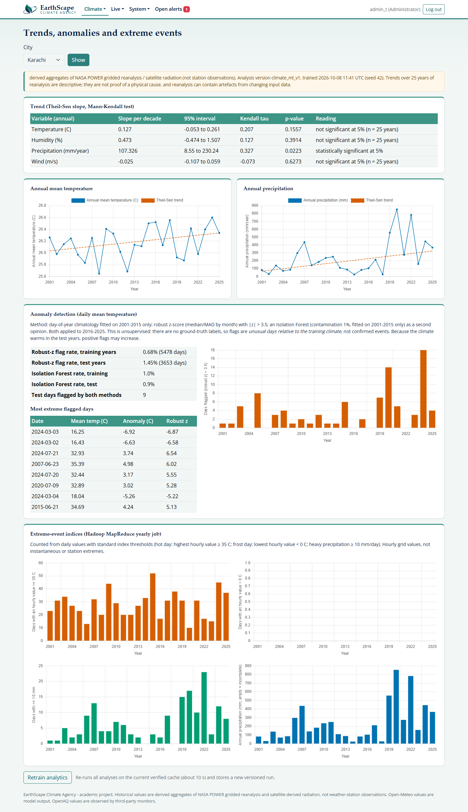
Figure F. Trends and Extremes: Theil-Sen trends, anomaly counts and extreme-event counts from the yearly MapReduce job
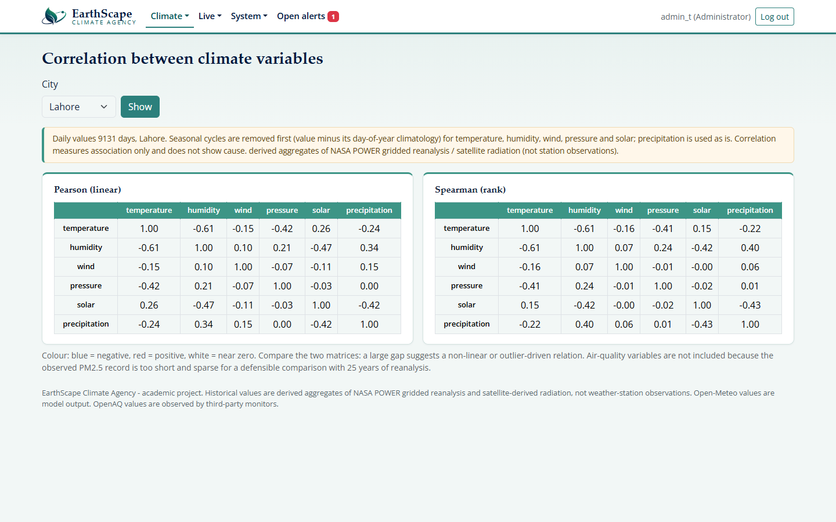
Figure G. Correlation of deseasonalised daily variables (association, not causation)
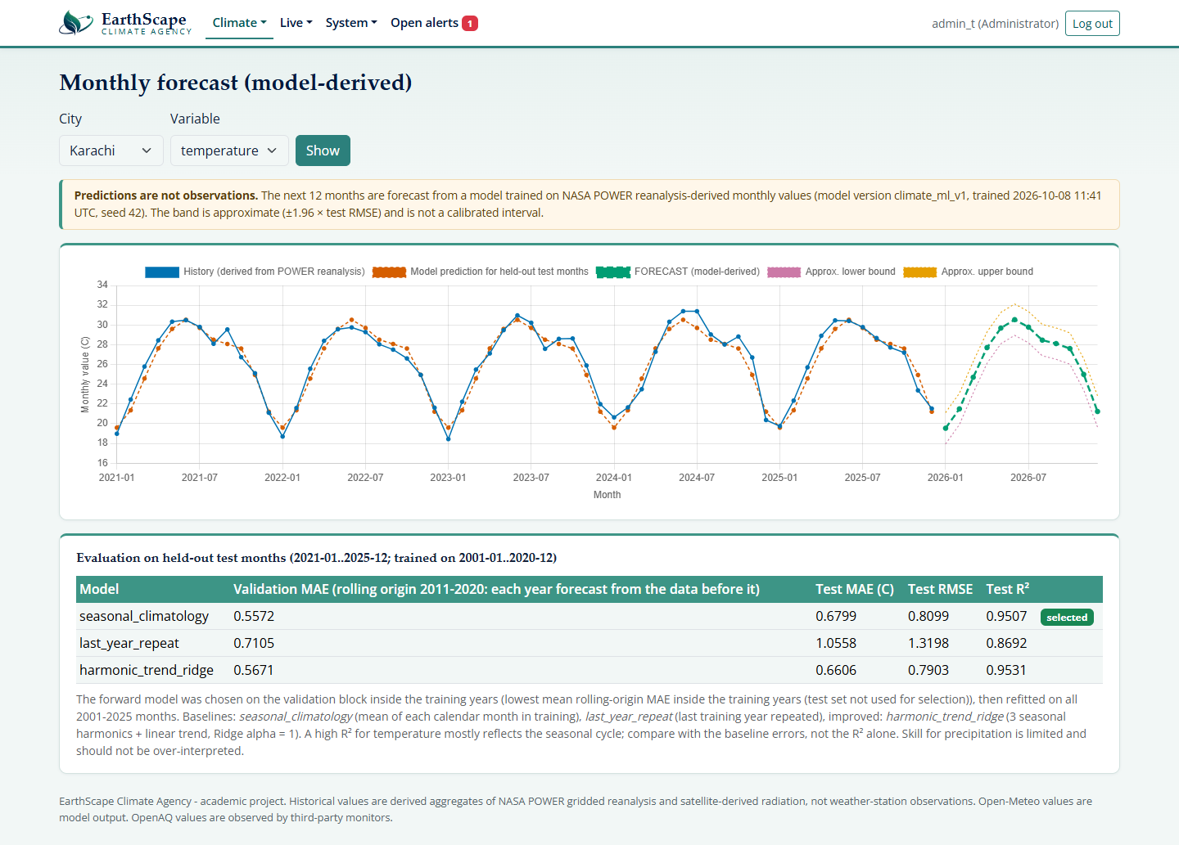
Figure H. Forecast: model-derived values, shown apart from observations, with held-out test results

Live data, historical comparison and alerts
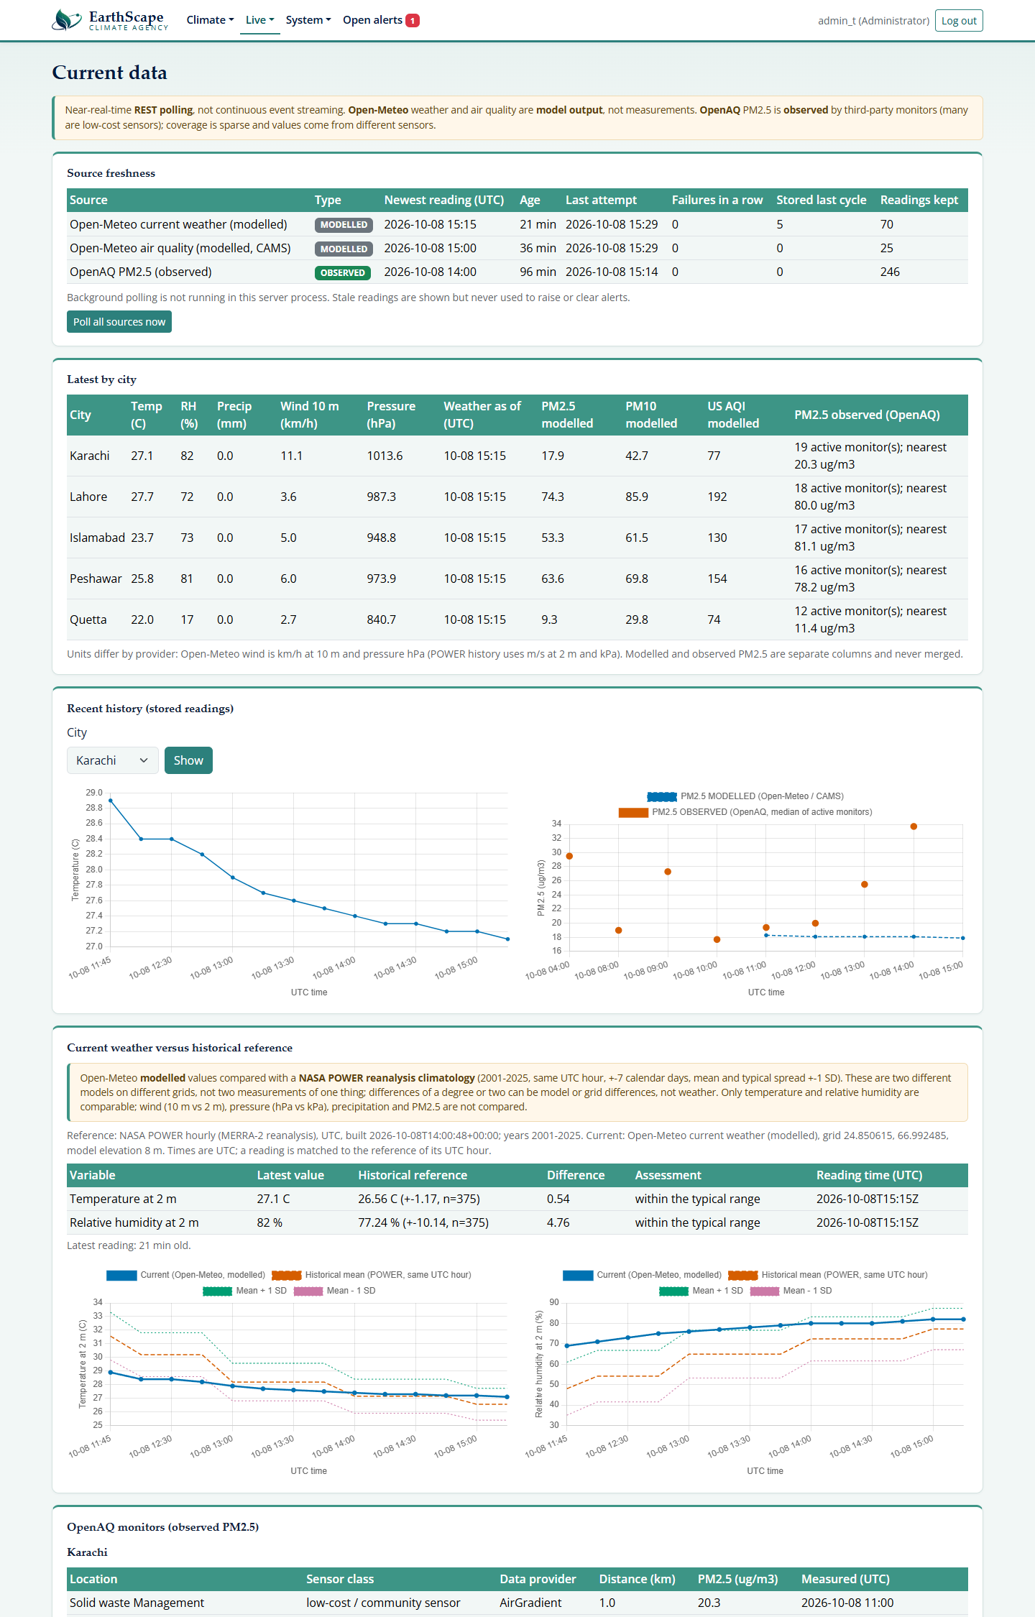
Figure I. Current Data: source freshness, modelled and observed values, and the current-versus-historical comparison (top of page)
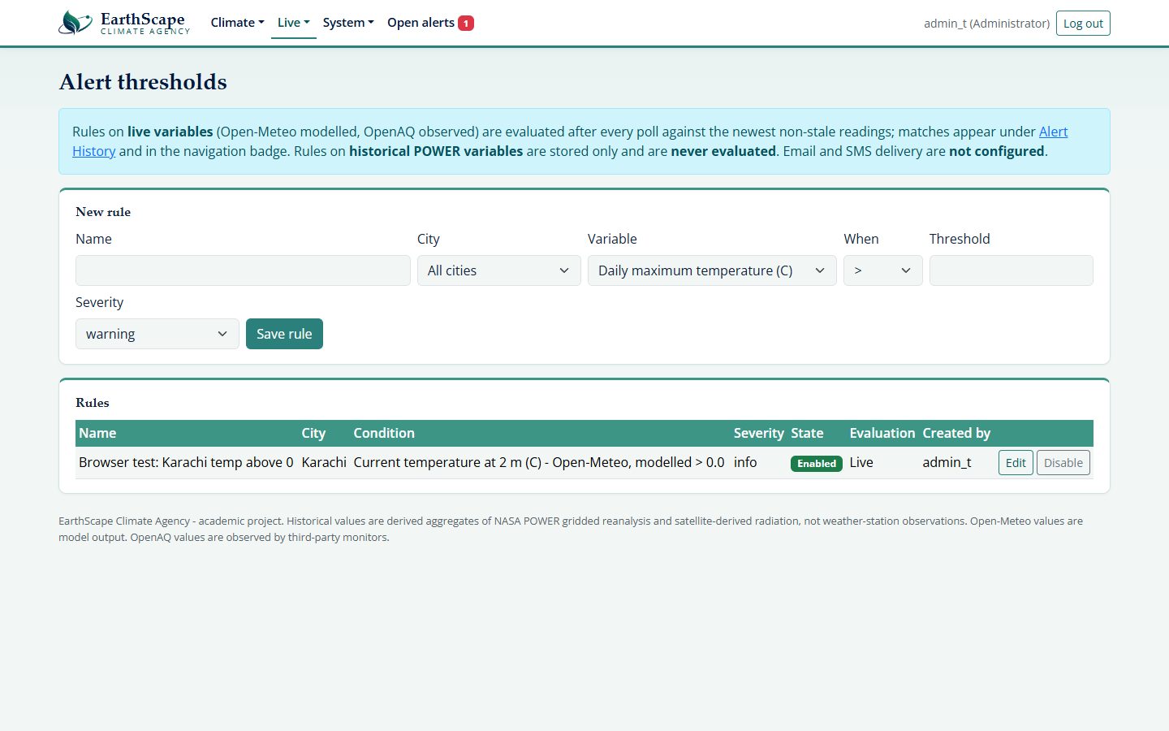
Figure J. Alert Rules: configurable thresholds on live variables
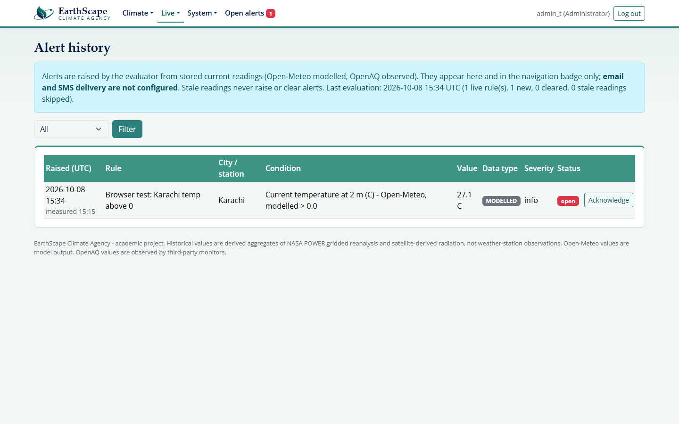
Figure K. Alert History: raised alerts with value, unit, source and acknowledgement

Provenance, feedback and mobile use
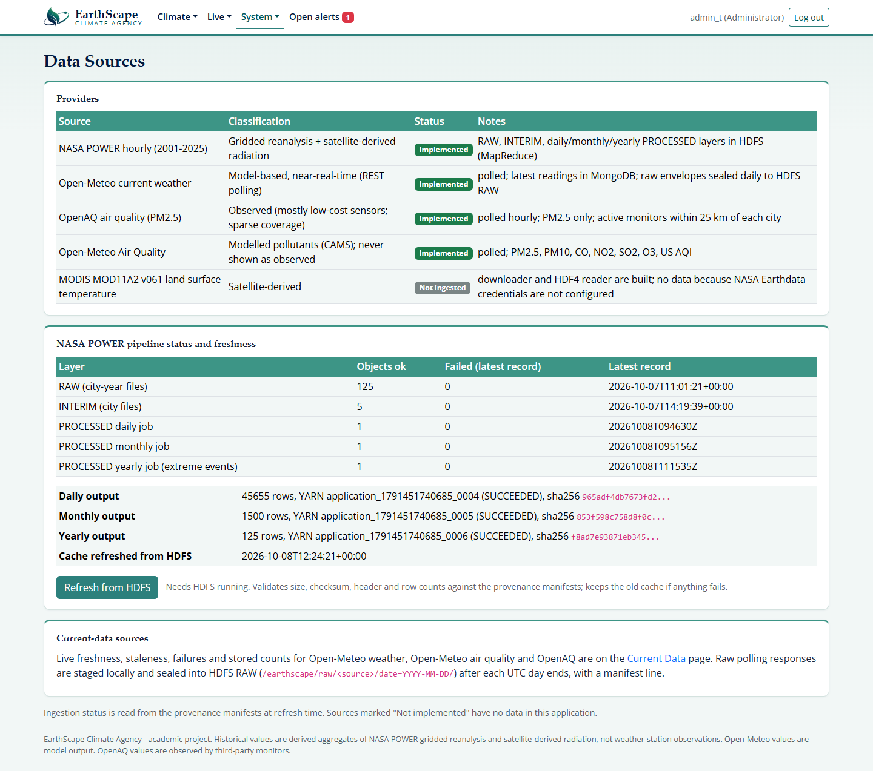
Figure L. Data Sources: provider classes, provenance and pipeline status
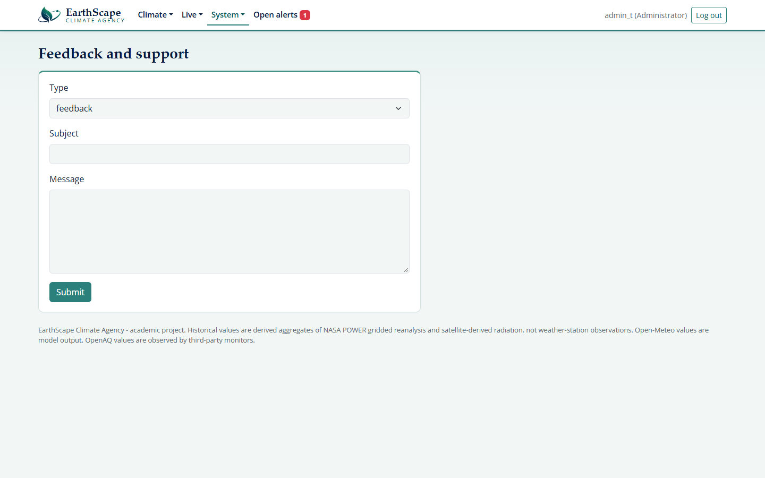
Figure M. Feedback and support form
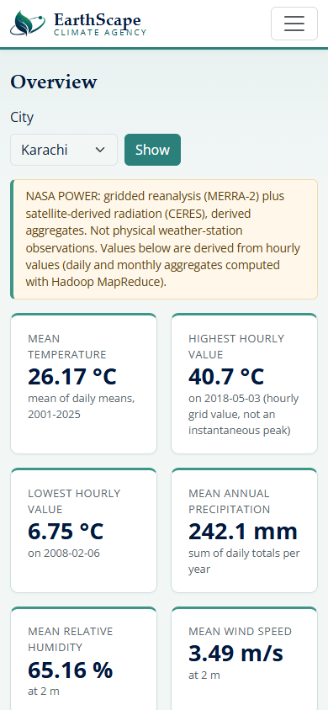
Figure N. The dashboard on a 390 px wide phone screen

As-Built Implementation Notes
The proposed designs earlier in this document asked for the collection names and algorithms to be aligned with the final implementation. The tables below describe what was actually built.

Database design as built (MongoDB database earthscape)
Collection | Purpose | Relation to the proposed design
users | accounts: username, Argon2id password hash, role (Administrator / Analyst), active flag, lockout data | USERS (no e-mail field)
sessions | server-side login sessions (token hash, CSRF token, expiry) | added for authentication
alert_rules | city, variable, operator, threshold, severity, enabled | ALERT RULES
alerts | raised alerts: value, unit, source, modelled/observed tag, status, acknowledged by | ALERT EVENTS (no delivery_status; alerts are in-app only)
latest_readings | normalised live readings from Open-Meteo and OpenAQ, unique per source/city/station/time, 30-day expiry | stands in for DATASETS of live sources
ingest_status | last attempt, success, failures and cycle duration per source | monitoring (not in the proposal)
ml_runs | versioned analytics runs: trends, anomalies, correlation, forecasts, seed | MODEL VERSIONS and PREDICTION RESULTS combined
feedback | support requests and feedback with status | added for the feedback requirement

DATA SOURCES, DATASETS and PROCESSING JOBS for the historical data are not MongoDB collections: they are append-only provenance manifests in HDFS (/earthscape/_manifest/*.jsonl) holding source, size, SHA-256, record counts and the YARN job and application identifiers. Raw, interim and processed files are in HDFS and are not duplicated in MongoDB.

Machine-learning methods as built
Proposed | Implemented | Note
Linear Regression (trend) | Theil-Sen slope with Mann-Kendall test for trends; Ridge regression on a linear trend plus annual harmonics for forecasts | Ridge is regularised linear regression; chosen by rolling-origin validation against seasonal baselines
Random Forest Regression | not implemented | no experiment was run; nothing is claimed for it
Isolation Forest (anomaly) | Isolation Forest plus a robust z-score rule, both fitted on 2001-2015 only | no labelled anomalies exist, so precision and recall are not reported
Correlation | Pearson and Spearman on deseasonalised daily anomalies | association only

Other differences from the proposal that the team should know: near-real-time REST polling replaces event streaming; alerts are shown in the application (no e-mail or SMS); MODIS satellite data and weather-station records are not ingested; TLS and encryption at rest are prepared or documented but not active; there is no dataset upload page (data enter through the ingestion scripts); and a dedicated audit trail of logins, role changes and configuration changes is not implemented.

Testing & Troubleshooting

Testing will verify that EarthScape Climate Agency meets its functional requirements and handles invalid data, access restrictions, and processing failures appropriately. Actual outcomes will be recorded after the tests are executed.
Testing Plan

Test Area | Test Scenario | Expected Result
Authentication | Attempt login with valid and invalid credentials | Valid users gain access; invalid attempts are rejected
Authorization | Attempt a restricted action using an analyst account | Access is denied according to the assigned permissions
Data Ingestion | Import a supported dataset and an unsupported file | Valid data is accepted; unsupported files receive a clear error
Data Validation | Submit records with missing fields or invalid measurements | Invalid records are logged and separated for review
Data Cleaning | Process duplicate records and inconsistent units | Duplicates are handled and measurements are standardized
HDFS Storage | Store and retrieve a sample dataset | Data is accessible at the configured location
Distributed Processing | Run a MapReduce job on a known sample | Results match independently calculated expected values
Streaming | Submit new observations through the configured streaming source | Observations are processed without unintended duplication
Machine Learning | Evaluate models using unseen data | Evaluation metrics are recorded without training-data leakage
Dashboards | Apply location and date filters | Visualizations show the corresponding records accurately
Alerts | Test values below, at, and above a configured threshold | Alerts follow the defined threshold rules
Backup and Recovery | Restore a test backup | Required data is recovered and verified
Performance | Run processing and dashboard tasks with increasing data volumes | Response times and resource usage are recorded

Each test record will include a test ID, inputs, expected result, actual result, status, and supporting evidence.

Troubleshooting Guide

Issue | Checks and Corrective Action
Application fails to start | Review startup logs, dependencies, environment settings, and port availability
Database connection fails | Check MongoDB service status, connection settings, credentials, and network access
HDFS is unavailable | Check Hadoop services, filesystem configuration, storage capacity, and permissions
Dataset import fails | Check file format, required fields, encoding, and validation logs
Processing job fails | Review job logs, input paths, schema compatibility, and available resources
Predictions fail | Check model files, preprocessing settings, feature names, and dependency versions
Dashboard shows no data | Check source connectivity, processing outputs, filters, and refresh settings
Alerts are missing or repeated | Check threshold rules, notification configuration, and duplicate-event handling
Processing is slow | Review dataset partitioning, job configuration, and CPU, memory, and storage usage

Security & Access Control

EarthScape Climate Agency will use authentication, role-based permissions, and data protection measures to control access to application functions and climate datasets.
1. User Authentication
Users will log in using unique accounts. Passwords will be stored using a suitable salted password-hashing method. Login sessions will expire after a configured period, and logout will invalidate the active session. Repeated failed login attempts will be restricted.
2. Role-Based Authorization
Permissions will be enforced on the server for every protected operation.
Role | Intended Permissions
Administrator | Manage accounts and roles, configure data sources and alert rules, and oversee system operations
Analyst | Explore authorized datasets, perform permitted analysis, and view dashboards, predictions, and alerts

Administrative functions will be restricted to authorized administrators. Users will receive only the permissions required for their responsibilities.

3. Data Protection
Sensitive data will be protected during transmission using encrypted connections and during storage using appropriate encryption controls. HDFS directories and database resources will have access permissions consistent with application roles and service requirements.
4. Input and Upload Validation
Uploaded files and user inputs will be validated before processing. Controls will check supported formats, file sizes, required fields, and acceptable values. Database operations will avoid directly interpreting untrusted input as executable queries or commands.
5. Credential Management
Database passwords, service credentials, and encryption keys will be kept outside source code in protected configuration or secret storage. Credentials will not be included in public repositories, screenshots, or logs.
6. Audit Logging
Relevant events—including login attempts, role changes, dataset imports, and configuration updates—will be recorded with timestamps and responsible user identifiers where applicable. Access to audit logs will be restricted.

7. Backup and Recovery
Backups will be protected against unauthorized access and stored separately from active data where practical. Restoration procedures will be tested to confirm that essential data and configuration can be recovered.
8. Security Maintenance
Dependencies and security settings will be reviewed regularly. Unused accounts will be disabled, permissions will be checked, and identified vulnerabilities will be addressed and retested.

Database Design
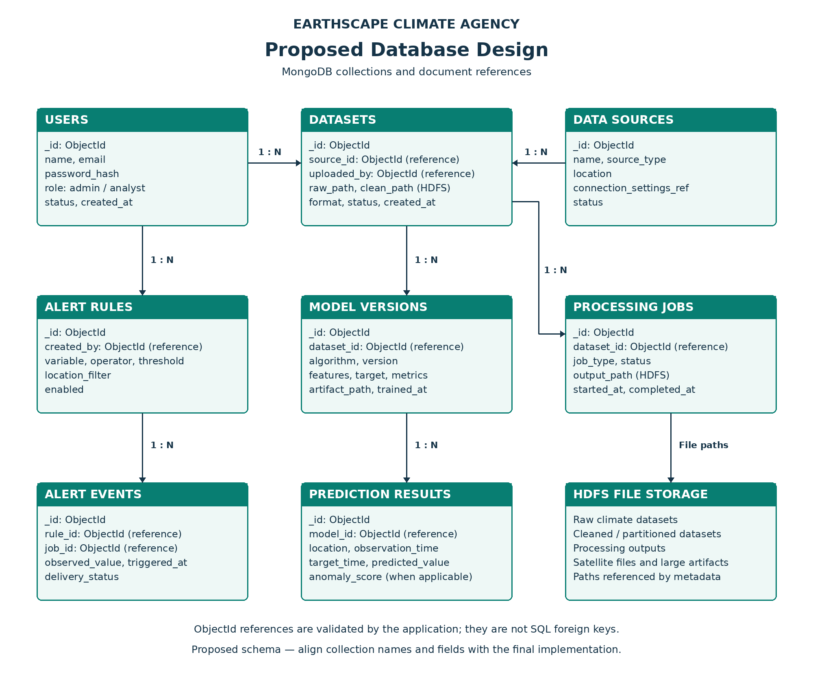

Conclusion

EarthScape Climate Agency proposes a big data analytics platform for collecting, storing, processing, and analyzing climate-related data. It brings together distributed storage, climate analysis, machine learning, and interactive visualization to support the exploration of environmental conditions.
Hadoop and HDFS provide the foundation for managing large datasets, while predictive models and anomaly detection methods aim to turn processed observations into useful insights. Dashboards and configurable alerts will help users explore findings and identify conditions that require further attention.
The project’s effectiveness will depend on data quality, successful integration of its components, and validation through testing. Overall, EarthScape Climate Agency provides a foundation for applying big data technologies to climate monitoring and informed environmental planning.

Future Enhancements

The platform could be extended through the following improvements:
- Broader Data Coverage: Integrate additional weather stations, satellite datasets, and environmental sensors to improve geographical coverage.

- Advanced Forecasting: Evaluate time-series and deep learning models against existing baselines to improve predictions where supported by the data.
- Interactive Geospatial Maps: Add map-based exploration of observations, anomalies, and predictions across regions.
- Prediction Uncertainty: Display confidence or prediction intervals to help users understand the reliability of model outputs.
- Improved Data Quality Monitoring: Detect sensor faults, missing observations, and changes in incoming data automatically.
- Model Performance Monitoring: Track changes in prediction performance and support controlled retraining and model version management.
- Cloud Deployment: Explore cloud infrastructure to expand storage and processing capacity as demand increases.
- Mobile Access: Provide responsive dashboards and configurable mobile notifications for authorized users.
- Enhanced Reporting: Generate downloadable summaries for selected locations, variables, and time periods.
- External System Integration: Provide secure APIs for sharing authorized analytical results with research and environmental monitoring systems.

